1/ If someone just wants a car to get him from A to B, it is considered as __________.
a A danger to the environment
b A lifestyle product
c A functional product d A status symbol
2/ A __________ has “B” pillars between the front and the rear doors and carries 4 - 5 people.
a convertible b minivan
c sedan d station wagon
3/ A _________ that has a large rear door for loading items easily is available in three- and five-door models.
a hatchback b lift back
c sport-utility vehicle d Both a & b correct
4/ Features that can save your life are ______.
a fuel consumption b performance
c safety d brands
5/ I live in the country and there is no public transport, ______ I have to buy a car.
a as b because
c so d due to
6/ The cars are _____ the world with their exhaust gases.
a matching b melting
c polluting d constructing
7/ A(n) ______ is not suitable for large families.
a SUV b Estate
c Station wagon d Convertible
8/ A(n) ______ has low fuel consumption.
a Hatchback b SUV
c Pick up d Both a & c are correct.
9/ A(n) ______ is ideal for small parking spaces.
a Coupe b Hatchback
c Pick up d Both a & b are correct.
10/ Taking good care of your car can increase its ______.
a cylinders b resale value
c seats d headrest
11/ John is a twenty-year-old bank clerk. This is his first car and first job. He should buy a(n) _____.
a estate b limousine
c coupe d SUV
12/ Sue and Tom are young couple. Both have good jobs and like to be trendsetters. They should buy a(n) _____.
a limousine b estate
c SUV d convertible
13/ A(n) _____ is a wanderer - someone who likes to travel around.
a escape b rover
c innovate d camry
14/ There are important qualities for a car to first come ____.
a to the targets b at the market
c in the roads d on the market
15/ At the very least, the name should not mean anything _____ in another language.
a luck b bad
c lovely d good
16/ American car makers like to give their ______ names that remind people of the Wild West, full of adventure and danger.
a pick ups b coupe
c hatchback d SUVs
17/ When it starts raining, you need to switch on the ________ to clear the windscreen.
a sunroofs b rear windows
c doors d windshield wipers
18/ The ________ absorb small impacts in an accident.
a front bumper b windshield wipers
c rear bumper d Both a & c are correct.
19/ Could you wind your _______ down to let a little air in?
a rear window b windshield
c side window d door handle
20/ "What model is that?’ ‘ I don’t know. I can’t see the ________ from here.’
a antenna b license plate
c headlight d badge
21/ The data carrier contains all the customer's ________ and communicates.
a components b specifications
c final checks d add-on parts
22/ The _______ - the doors, boot lid, and bonnet- are then mounted to make the _______.
a add-on parts/ body-in-white
b body shells/ floor pan c floor pans/ body shell
d body-in-white/ add-on parts
23/ Almost every car ______ to the customer's specifications.
a produced b were produced
c are produced d is produced
24/ German cars ______ all over the world.
a are sold b is sold
c are being sell d have sold
25/ Use a jack to _____ the vehicle.
a raise b gear
c tighten d loosen
26/ Do you ever have problems ______ suppliers?
a at b for c with d from
27/ I'll be _____ my office until 4pm.
a on b in
c at d Both a & b are correct.
28/ I'll look _____ the problem straight away and get back _____ you as soon as I can.
a for/ with b into/ to
c into/ with d for/ of
29/ I've got your mobile number, but can you give it ____ me again just ____ case.
a to/ at b to/ in
c to/ on d for/ in
30/ The second discipline in 8D report is problem ______.
a implemented b description
c recurrence d containment
31/ The third discipline in 8D report is ______ actions.
a root b containment
c responsible d implemented
32/ People have got used to the sight of very small car ______ in tiny parking spaces.
a parking b park
c parks d parked
33/ In 1998, smart became a 100% ______ of what was then Daimler-Benz AG
a premiere b subsidiary
c containment d comment
34/ There’s usually a cosmetic mirror on the passenger’s __.
a sun visor b door
c sunroof d side window
35/ You put your cigarette in the ______ when it's finished.
a clutch pedal b ashtray
c ignition d cup holder
36/ Those _________ can be filled up with air to stop your head being injured if you crash.
a side window b sunroof
c gearstick d airbags
37/ I have a leather __________. It’s not so cold for my hands in the winter and it gives me a good grip.
a steering wheel b ignition
c car seat d sunroof
38/ You must fasten your _______ to protect yourself if there is an accident.
a seat belt b sunroof
c steering wheel d car seat
39/ A(n) _______ is operated by hand and normally used when the car is not moving.
a brake pedal b clutch pedal
c accelerator d handbrake
40/ Press the _________ in order to increase speed.
a clutch pedal b accelerator
c brake pedal d ignition

1/ Open the _____ to let some sun and fresh air into the car.
a exhaust pipe b badge
c windshield wipers d sunroof
2/ That convertible has a nylon _____ that can be raised or lowered.
a side window b sunroof
c antenna d roof
3/ The Mercedes star is a well-known _________.
a logo b license plate
c turn signal d wheel trim
4/ It is important to inflate the _______ to the correct pressure for better fuel consumption.
a license plate b logo
c resale value d tires
5/ Lock the ________ closely or the gasoline can leak out.
a door handle b exhaust pipe
c gas tank lid d door
6/ A _____ allows vision out of the back of the car.
a windshield b sunroof
c rear window d Both a & b are correct.
7/ Don’t forget to retract the ___ before using the car wash.
a side windows b doors
c sunroof d antenna
8/ Don't open the ______ while driving. It's so dangerous.
a door b sunroof
c side window d Both b & c are correct.
9/ Weekly and daily production schedules are created and ______ to suppliers.
a be sent b send
c to send d sent
10/ Finally, remove the old tyre from under the vehicle and _____ the vehicle.
a raise b lower
c increase d loosen
11/ Put the vehicle in to _____ (manual transmission) or ______ (automatic).
a gear/ park b nut/ jack
c park/ gear d jack/ nut
12/ Use a jack to _____ the vehicle.
a loosen b gear
c raise d tighten
13/ Can you tell me what the failure _____ is exactly?
a nut b rate
c tight d boot
14/ The fourth discipline in 8D report is ______ causes.
a responsible b implemented
c selected d root
15/ The fifth discipline in 8D report is ___ long-term actions.
a selected b containment
c responsible d recurrence
16/ The seventh discipline in 8D report is action to prevent ______ of problem.
a recurrence b current
c selected d implemented
17/ Smart cars appeal ______ people who are sporty, independent, and young at heart.
a at b for c with d to
18/ There’s usually a cosmetic mirror on the passenger’s __.
a side window b sun visor
c sunroof d door
19/ Those _________ can be filled up with air to stop your head being injured if you crash.
a sunroof b side window
c gearstick d airbags
20/ It’s against the law to phone while driving so I’ve ordered a car with a _________.
a ignition b cup holder
c dashboard d hands-free telephone
21/ Could you have a look in the road atlas? It’s in the ____.
a side window b door handle
c roof d glove compartment
22/ Could you close the ________? I’m getting a draught.
a air vent b rear widow
c windshield d Both a & c are correct.
23/ I often put some magazines and newspapers in the ______ on my left door.
a cup holder b dashboard
c brake pedal d door tray
24/ You must fasten your _______ to protect yourself if there is an accident.
a sunroof b seat belt
c steering wheel d car seat
25/ Press the _________ in order to increase speed.
a clutch pedal b brake pedal
c ignition d accelerator
26/ The ___ show that you are indicating to turn left or right.
a turn signals b warning lights
c indicator lights d All are correct.
27/ What do you do when your steering wheel is too high?
a adjust the steering wheel
b check the tyre pressure
c open the sunroof
d adjust the rear-view mirror
28/ What do you do when your passenger has no legroom in the back?
a open the glove compartment
b adjust the seat position
c check the oil level
d check the tyre pressure
29/ I'm looking forward ______ from you soon.
a to hear b to hearing
c hearing d hear
30/ There needs to be an optimal _____ between visual displays and voice instructions.
a standard b problem
c balance d distraction
31/ Designers reduce the size of ______ such as heating and cooling systems.
a telematics b space-eaters
c spacious d overcrowd
32/ If the touch screens are overcrowded, they could distract the drivers and cause _____.
a accidents b luxury
c traffic d space-eaters
33/ The touch screens should be placed high so that drivers can use it while ______.
a to drive b be driving
c driving d are driving
34/ The ________ is similar to the station wagon, but it is designed to carry 12 passengers.
a convertible b hatchback
c minivan d sedan
35/ A ________ has a mobile roof.
a sport-utility vehicle b sedan
c convertible d station wagon
36/ The_____ TT can run as fast as 400km/h.
a Smart b Panda
c Audi d None is correct.
37/ The fastest a car can go is ______.
a interior features b top speed
c performance d fuel consumption
38/ Features that can save your life are ______.
a safety b fuel consumption
c performance d brands
39/ Tommy has just bought the car with powerful engine and the _____ equipment.
a last b lastest
c later d latest
40/ A(n) ______ is good for bad roads.
a Pick up b Convertible
c SUV d Both a &c are correct.

ĐỀ KIỂM TRA UNIT 1-2-3
HỌC KỲ: II NĂM HỌC: 2016 – 2017 Thời gian: 45’
Đề 1

Bậc đào tạo: TRUNG CAP Học phần: ANH VĂN CN O TO

PHIẾU TRẢ LỜI TRẮC NGHIỆM
Tên: ______________________________________ Lớp: ________ STT: _______
Tô đen những câu trả lời đúng. Mỗi câu chỉ tô 1 đáp án.
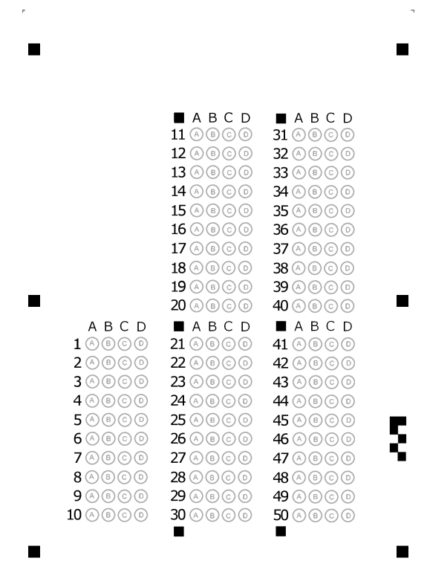

Mã đề 1

1[ 1]c... 2[ 1]c... 3[ 1]d... 4[ 1]c... 5[ 1]c... 6[ 1]c... 7[ 1]d... 8[ 1]a...
9[ 1]d... 10[ 1]b... 11[ 1]c... 12[ 1]d... 13[ 1]b... 14[ 1]d... 15[ 1]b... 16[ 1]d...
17[ 1]d... 18[ 1]d... 19[ 1]c... 20[ 1]d... 21[ 1]b... 22[ 1]a... 23[ 1]d... 24[ 1]a...
25[ 1]a... 26[ 1]c... 27[ 1]b... 28[ 1]b... 29[ 1]b... 30[ 1]b... 31[ 1]b... 32[ 1]d...
33[ 1]b... 34[ 1]a... 35[ 1]b... 36[ 1]d... 37[ 1]a... 38[ 1]a... 39[ 1]d... 40[ 1]b...

Mã đề 2

1[ 1]d... 2[ 1]d... 3[ 1]a... 4[ 1]d... 5[ 1]c... 6[ 1]c... 7[ 1]d... 8[ 1]a...
9[ 1]d... 10[ 1]b... 11[ 1]a... 12[ 1]c... 13[ 1]b... 14[ 1]d... 15[ 1]a... 16[ 1]a...
17[ 1]d... 18[ 1]b... 19[ 1]d... 20[ 1]d... 21[ 1]d... 22[ 1]a... 23[ 1]d... 24[ 1]b...
25[ 1]d... 26[ 1]d... 27[ 1]a... 28[ 1]b... 29[ 1]b... 30[ 1]c... 31[ 1]b... 32[ 1]a...
33[ 1]c... 34[ 1]c... 35[ 1]c... 36[ 1]c... 37[ 1]b... 38[ 1]a... 39[ 1]d... 40[ 1]d...

_______Hết_______

